Input Validation Issues Part -2

Navigate to DIVA

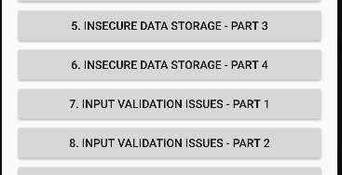

This exploit requires checking URL reach in the input validation. Which we can see which we enter in the text box.

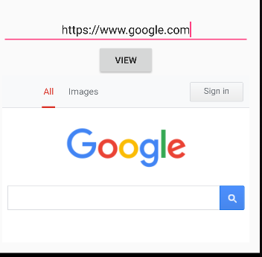

If we can reach a URL that means we can access localhost data as well, let’s check a credential we had entered in the previous challenges to verify this, by going to this path : <file:///data/data/jakhar.aseem.diva/shared_prefs/jakhar.aseem.diva_preferences.xml>

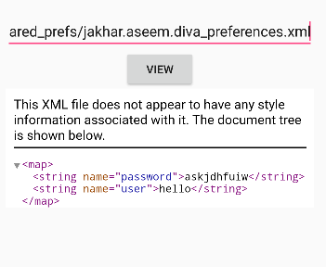

We can see that the user can access all user credentials through file traversal hence exploiting input validation vulnerability.

